Table of Contents

Learning Journey Assistant — Data and Algorithm Pipeline
Version | 2.0, 3 October 2026. Supersedes the 11 August 2026 page, which described the target design before any of it ran.
Describes | main at b4ccebd (3 Oct 2026), after pull requests #52 to #54 and #25; the opt-in Generate button is in open PR #55
Source | docs/design/data-and-algorithm-pipeline.md; diagrams rendered from docs/handover/diagrams/*.mmd. Rebuild with docs/design/build.sh
Companions | CLI Pipeline (what one lja.cli run does), UML Use Case and Sequence Diagrams, the System Maintenance Document (the full reference) and the User Document (how to read the dashboard)

How a mark becomes a recommendation
Seven stages, one algorithmic core. Everything before gap detection is plumbing that produces one in-memory dataset; everything after it is presentation or generation that reads the gap engine’s verdicts. The language model is allowed to see structured data only, and every name it returns is checked against that data before anything is written.
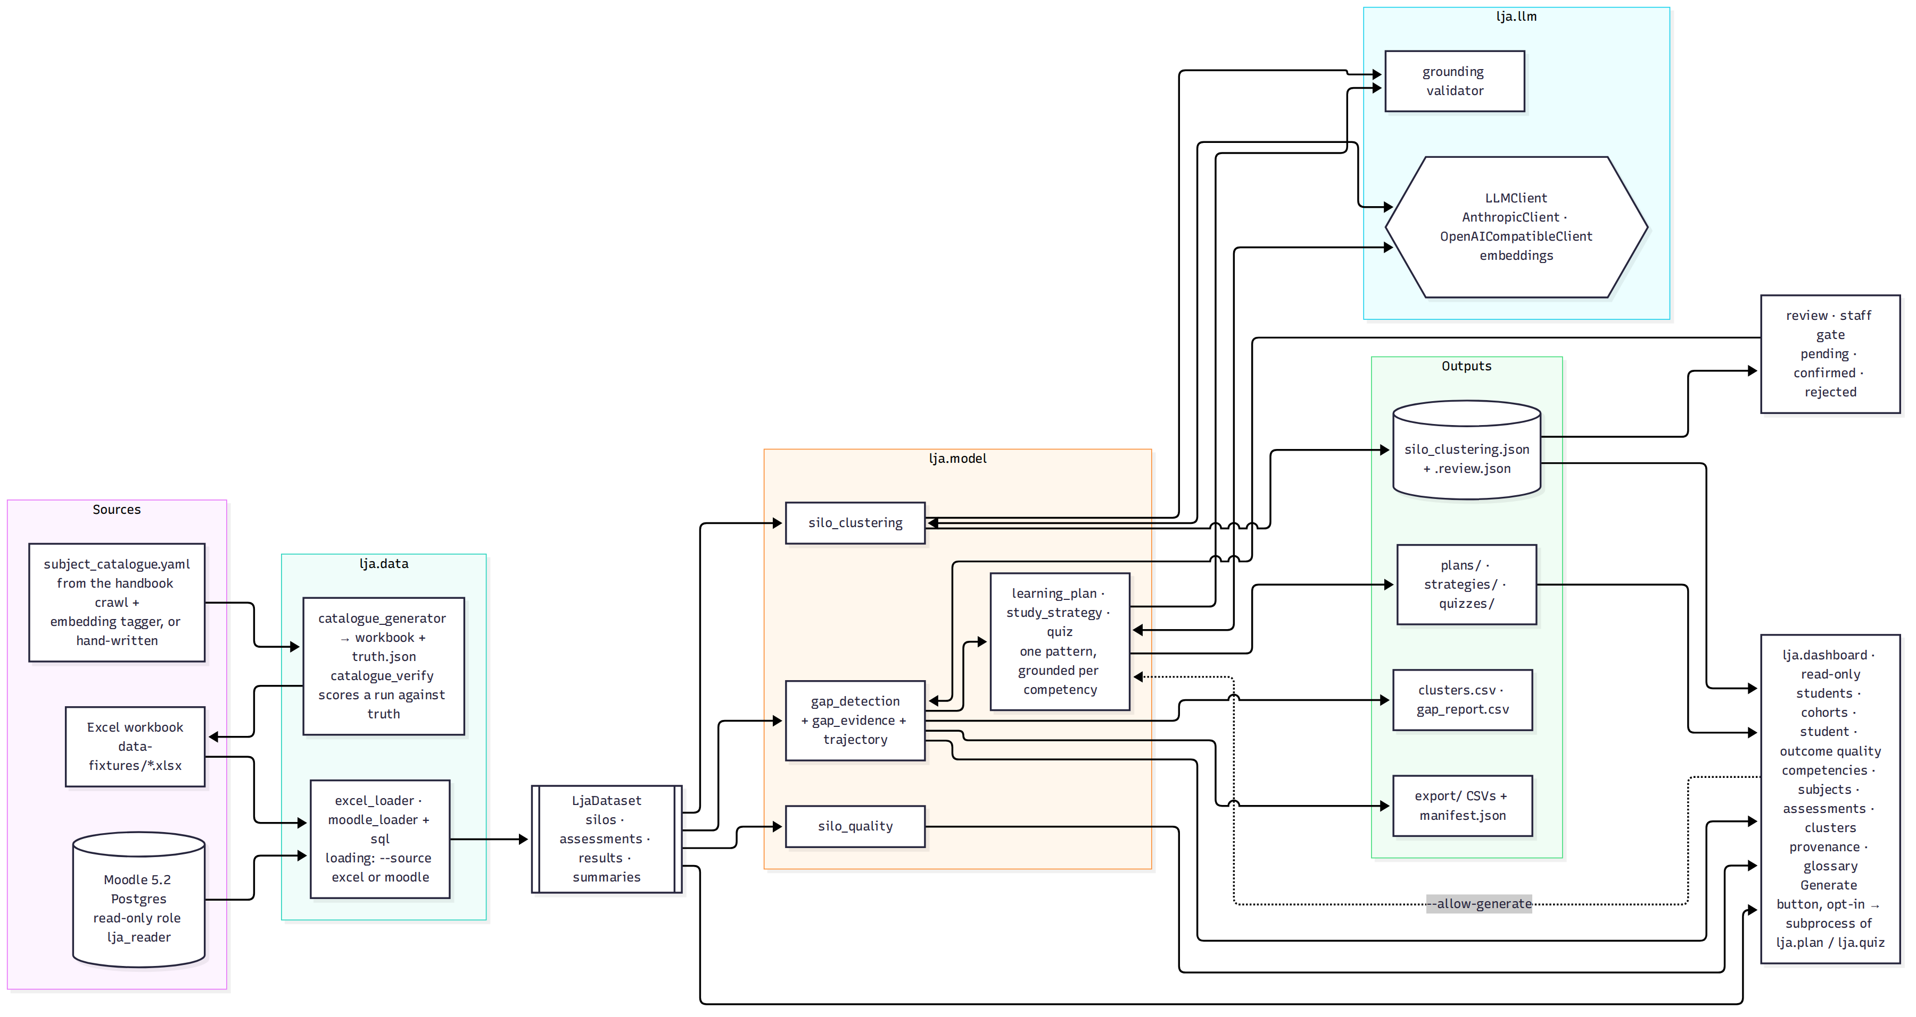
LJA architecture
Figure 1: Sources, data layer, the LjaDataset interchange type, model layer, LLM layer, outputs and dashboard. Source: docs/handover/diagrams/01-architecture.mmd.
Stage | Owning code | Input | Output | Status, 3 Oct 2026
Sources | data-fixtures/, devenv/, lja.data.handbook, lja.data.catalogue_generator | The owner’s workbook; a Moodle 5.2 database; the public La Trobe handbook; a subject catalogue | A workbook, or rubric fills, or a synthetic cohort with an answer key | Working. Moodle proven for one seeded subject with read-only enforcement observed (IOLG-111). The handbook crawl and the 100-subject, 5,000-student cohort are reproducible but not committed.
Extraction | lja.data.excel_loader, lja.data.moodle_loader + sql/, lja.data.loading | Workbook sheets, or SQL Query 2 over the rubric tables plus a staff-edited criterion-to-SILO map | One LjaDataset: SILOs, assessments, result rows, student summaries | Working. Both loaders produce the same type; --source excel or moodle on every command.
Clustering | lja.model.silo_clustering, lja.llm | SILO wording | Competency clusters with a label and rationale, cached as silo_clustering.json | Working with coverage validation and retry. Single-call clustering fails above about 50 SILOs; the embedding tagger in lja.data.competency_tagger is the staged answer (ADR 0002 trigger hit).
Staff gate | lja.review | The cache | .review.json with pending / confirmed / rejected per cluster | Working, CLI only. A rejected cluster stops the pipeline; pending needs --allow-unconfirmed; the dashboard shows a banner.
Gap detection | lja.model.gap_detection, gap_evidence, trajectory | Dataset plus confirmed clusters | gap_report.csv: attainment, classification, its basis, relative position; per-subject evidence; trend along the declared subject sequence | Working. Relative to the student’s own profile (median and MAD) with absolute guards; every threshold is configuration and unratified (A-01).
Generation | lja.model.learning_plan, study_strategy, quiz; lja.llm.grounding | This student’s gaps, evidence, SILO wording, own scores and feedback | learning_plan_<id>, study_strategy_<id>, quiz_<id>, JSON and Markdown, written only after grounding passes | Working. Plans and strategies reliable; the quiz is a thin slice whose answer key cannot be verified, and it fails for students with many gaps on the local model (per-competency generation is the follow-up).
Presentation and export | lja.dashboard, lja.export | Dataset, gaps, cache, generated files | Students, cohorts and priority groups; student page with gaps, strengths, progress, subject chain, plan, quiz; outcome quality, competencies, subjects, assessments, clusters; provenance; glossary. Three research CSVs and a manifest, pseudonymised | Working. The dashboard never calls a model on a page load; the opt-in Generate button (PR #55) runs the CLI as a subprocess.

What the gap engine does
The owner’s primary signal is variability within a student’s own profile, not raw failure. For each student and competency the engine computes a weighted attainment, then classifies it in a fixed order: below the absolute floor is a gap; at or above the absolute ceiling is proficient; a profile with too few competencies or too flat a spread falls back to an absolute split and says so; otherwise the position in MAD units below or above the student’s own median decides. A gap evidenced in two or more subjects is persistent, otherwise isolated. Every row carries the rule that decided it, so no displayed figure is unexplained.
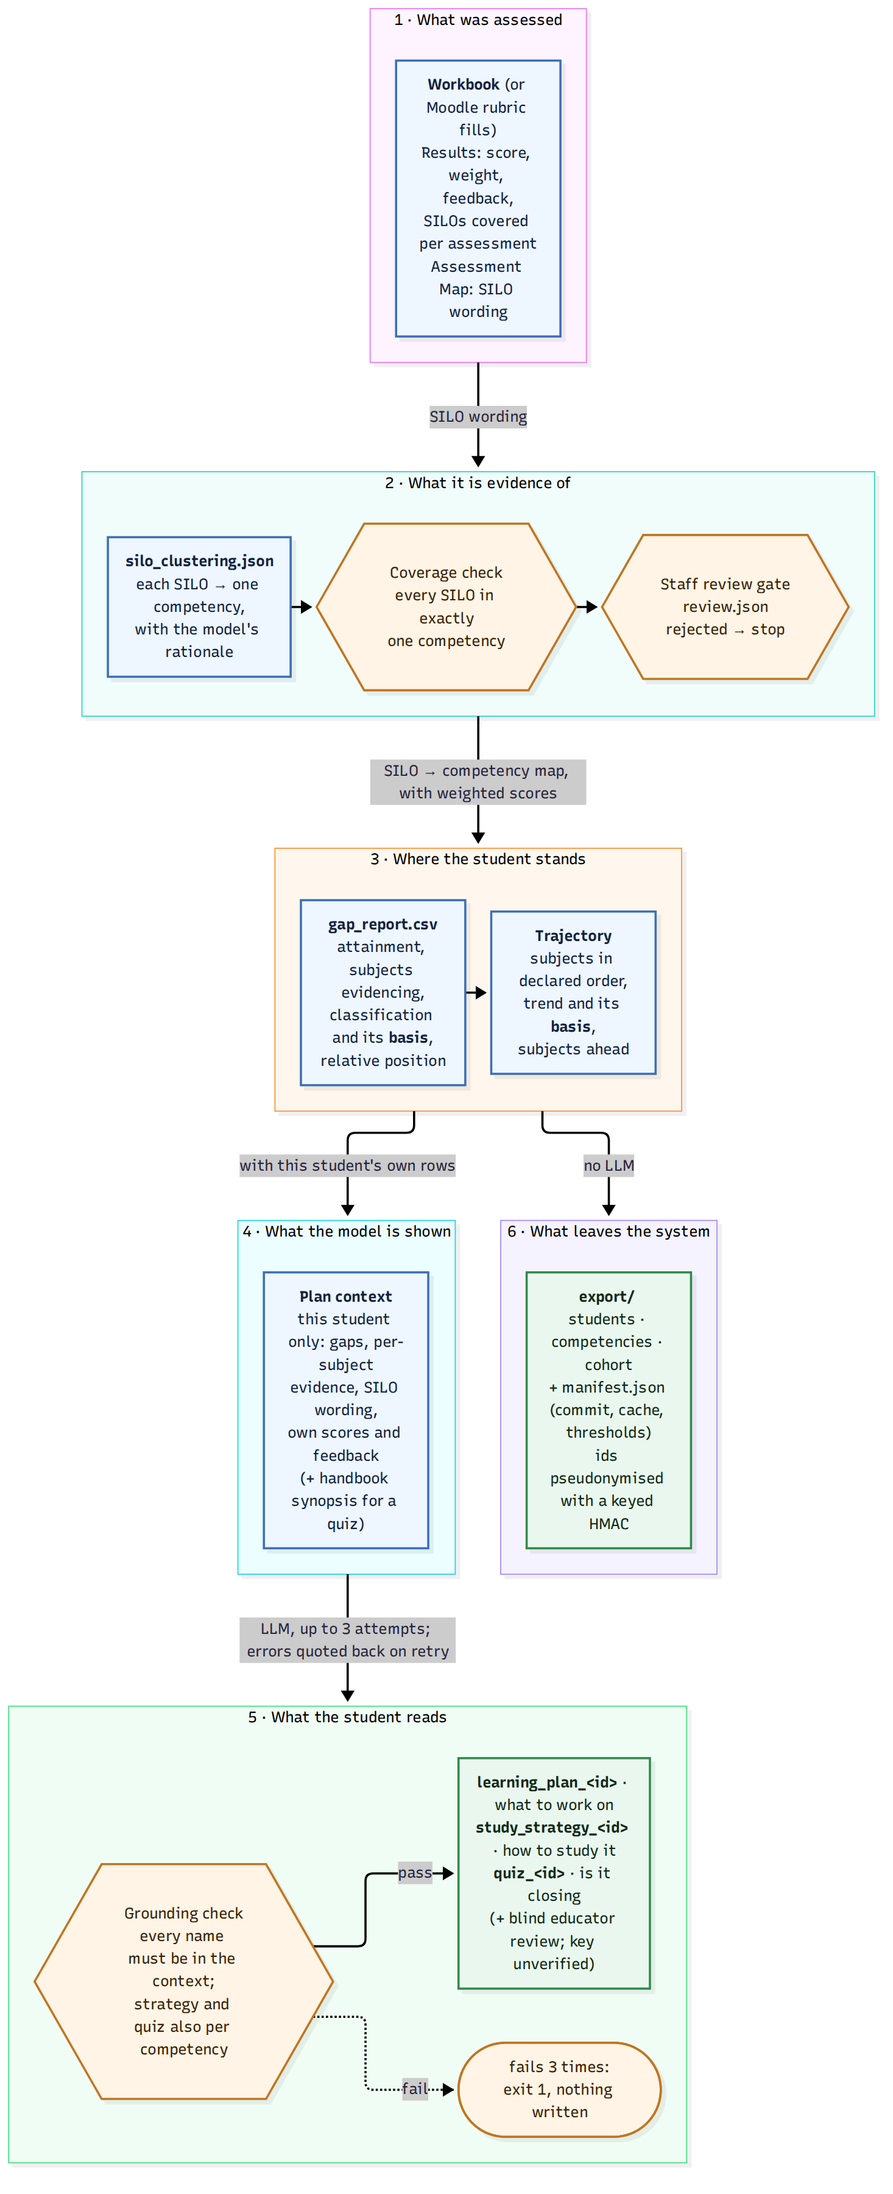
Evidence lineage
Figure 2: What each stage leaves behind and the check between stages, so any statement a student reads can be followed back to marked work. Source: docs/handover/diagrams/07-evidence-lineage.mmd.

Where the Moodle score comes from
Only the direct-SQL path can reach a rubric filling, the level a marker chose and their remark. Moodle’s Web Services expose a rubric’s definition but no function returns what was awarded. So the production path connects to PostgreSQL as the lja_reader role, which can only SELECT, and runs Query 2 in sql/moodle_attainment_extraction.sql. The loader joins those rows to a staff-editable criterion_silo_map_<SUBJECT>.csv; an unmapped criterion is a hard error, not a silent drop.
Moodle field | What it holds | Becomes
gradingform_rubric_fillings.remark | Marker’s comment on this one criterion | feedback_comment
grading_instances.status | Must equal 1 (active); 0, 2, 3 are stale, draft or superseded | filter only
grading_instances.itemid | Not a user id: joins to assign_grades.id, the common wrong join in this schema | join key
gradingform_rubric_criteria.description | The criterion’s own text | mapped to a SILO key via the CSV
gradingform_rubric_levels.score and the criterion’s maximum | Points awarded, and the ceiling | score, normalised to a percentage
assign.name, course.shortname, user.idnumber | Assessment, subject, student | assessment_name, subject_code, student_id
The 11 August design had a staging table named lja_criterion_score and a confirmed_by_staff gate on the criterion map. Neither was built that way. The in-memory LjaDataset is the staging table, and the staff gate moved one stage later, onto the LLM’s clustering, which is where the uncertainty actually is.
What was observed on 28 September 2026 (IOLG-111, docs/security-evidence.md): the role created from the DDL in sql/README.md; UPDATE m_user as lja_reader refused with permission denied; a data-only dump byte-identical before and after a pipeline run.

Trust boundaries
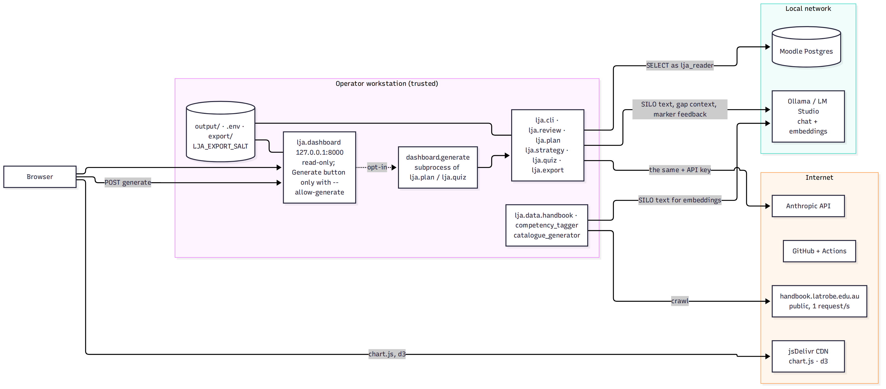
Trust boundaries
Figure 3: What crosses each boundary. Prompts carry SILO text, gap context and the student’s own marker feedback, never names beyond STU0001-style ids. Source: docs/handover/diagrams/06-trust-boundaries.mmd.

What changed since the August page
August 2026 said | October 2026
Extraction “partial, loader not coded”; mapping “schema only” | Both loaders working; the criterion map is a CSV, not a table
Gap detection “SQL drafted, not yet Python”, two fixed thresholds 50/65 | Python, relative to the student’s profile with seven configurable thresholds; SQL Query 6 kept as an annotated legacy
LLM layer “planned” | Two providers behind one protocol; clustering, plans, strategies and quizzes all grounded by code
Dashboard “planned”, four views | Fourteen pages, every count a link, provenance and glossary; opt-in generation
No research export, no synthetic data, no handbook | lja.export with pseudonyms; catalogue generator with planted gaps and an answer key; handbook crawl with an embedding tagger
Staff review gate on the criterion map | Gate on the clustering, with a dashboard banner and a CLI stop

